**Reliance Sales Analysis Using Power BI**

Business Intelligennce Mini Project

Submitted by

Rohan Khatode(Roll No : BA56)

Arnav Mahalpure(Roll No: BA63)

Aayush Bhalavi(Roll No: BA09)

Ashish Chandekar(Roll No: BA67)

FINAL YEAR COMPUTER ENGINEERING



Department of Computer Engineering

International Institute of Information Technology

Hinjawadi, Pune – 411057

SEMESTER II (AY 2024-25)

**TABLE OF CONTENTS**

**TITLE PAGE NO.**

1. ABSTRACT 1
2. INTRODUCTION 2
   1. SCOPE 2
   2. REQUIREMENT ANALYSIS 3
   3. SOFTWARE AND HARDWARE DETAILS 5
3. DATA SET DESCRIPTION AND LINK TO DATASET 6
4. OUTPUT 8
5. CONCLUSION 10

# ABSTRACT

In This Power BI dashboard provides a comprehensive overview of the sales performance of Reliance SMART across various product brands and geographic regions. The dashboard visualizes key business metrics such as total revenue (1.76M), total profit (1.05M), profit margin (59.67%), and total making cost (711.73K). It includes a detailed breakdown of product brand-wise quantity sold and highlights the distribution of revenue across global regions using an interactive map. A treemap visualization further categorizes regional transactions, helping to identify high-performing and low-performing zones. This dashboard empowers stakeholders with actionable insights to monitor profitability, track market reach, and optimize business decisions for future growth.

# INTRODUCTION

In today’s data-driven business environment, effective visualization and analysis of sales data is essential for informed decision-making and strategic planning. This project focuses on building an interactive Power BI dashboard for Reliance SMART, aimed at analyzing product sales performance across various regions. The dashboard consolidates critical business metrics such as total revenue, profit, product margin, and making cost. It also provides a brand-wise sales breakdown and regional transaction insights through geographical and treemap visualizations. The goal of this project is to deliver a clear, concise, and visually appealing representation of Reliance SMART’s sales data to support better business intelligence and performance tracking

.**2.1. SCOPE**

The scope of this Power BI dashboard project is to analyze and visualize the sales performance of Reliance SMART across different product brands and global regions. The dashboard focuses on the following key areas:

* **Sales Metrics Analysis:** Display and monitor total revenue, profit, making cost, and profit margin.
* **Product Performance:** Provide insights into brand-wise product sales by quantity sold.
* **Geographical Insights:** Highlight revenue distribution across regions using a world map and identify high-performing regions using a treemap chart.
* **Interactive Visualization:** Enable dynamic interaction and filtering for better user engagement and data exploration.
* **Business Decision Support:** Support stakeholders in making informed business decisions related to product strategy, pricing, and regional marketing.

This dashboard serves as a powerful tool for Reliance SMART’s business analysts and decision-makers to monitor tren**ds,** evaluate performance, and plan growth strategies based on real-time data.

**2.2. REQUIREMENT ANALYSIS:**

**Functional Requirements:**

· **Data Import and Integration:**

* The dashboard must be able to load sales data, product details, and regional data from various sources (Excel, CSV, databases, etc.)

· **Data Visualization:**

* Display key metrics such as Total Revenue, Profit, Profit Margin, and Making Cost using KPI cards.
* Visualize product brand-wise quantity sold in tabular format.
* Show revenue distribution on an interactive world map based on region-wise sales data.
* Represent regional sales transactions using a treemap for quick comparisons.

· **Filtering and Interactivity:**

Enable users to apply filters based on region, product brand, or time period to dynamically update visuals.

* Allow drill-downs for detailed analysis on specific metrics or regions.

· **User Navigation:**

* Provide a user-friendly interface for easy navigation across different report pages or visuals.

· **Real-Time or Scheduled Data Refresh:**

* Support scheduled data refresh to ensure the dashboard reflects the latest available data.

**Non-Functional Requirements:**

· **Performance:**

* The dashboard should load and respond quickly to user interactions, even with large datasets.

· **Usability:**

* The design should be intuitive and easy to use for both technical and non-technical users

· **Scalability:**

* Should be scalable to accommodate additional data sources, product categories, and regions in the future

· **Security:**

* Implement appropriate data security settings in Power BI to restrict access based on roles (if published or shared).

· **Maintainability:**

* The dashboard design and data model should be structured in a way that allows for easy updates or enhancements.

· **Portability:**

* The report should be accessible across devices (desktop, mobile, tablet) through the Power BI service.

**2.3. SOFTWARE AND HARDWARE REQUIREMENTS:**

### ****Software Requirements:****

| **Component** | **Details** |
| --- | --- |
| Operating System | Windows 10 or later (Power BI Desktop is Windows-only) |
| Power BI Tool | Power BI Desktop (for development) and Power BI Service (for publishing) |
| Data Sources | Microsoft Excel / CSV files / SQL Server / Other supported data connectors |
| Web Browser | Google Chrome, Microsoft Edge, or Firefox (for Power BI Service access) |
| Office Tools (Optional) | Microsoft Excel (for initial data cleaning or integration) |
| Version Control (Optional) | GitHub or Git for maintaining backup and version history |

### ****Hardware Requirements:****

| **Component** | **Minimum Requirement** | **Recommended** |
| --- | --- | --- |
| Processor | 1.4 GHz or faster, 2-core processor | 2.0 GHz or faster, 4-core or more |
| Storage | 2 GB of available space (for Power BI and data files) | SSD with 10 GB or more free space |
| Internet | Required for accessing online services (Power BI Service) | High-speed broadband connection |

# DATASET DESCRIPTION AND LINK OF DATASET

**Description**

The dataset used in this Power BI dashboard follows a **star schema model**, consisting of dimension tables (denoted by d_) and fact tables (denoted by f_). This structure enables efficient reporting and analysis of Reliance SMART’s sales data.

### ****Dimension Tables (d_):****

**d_Calendar**

* Contains date-related information such as year, month, quarter, and day.
* Used for time-based filtering and trend analysis.

**d_Customers**

* Holds details about customers, such as customer ID, name, segment, location, etc.
* Useful for customer segmentation and behavior analysis.

**d_Products**

* Includes product-specific data like product ID, product name, brand, and category.
* Enables analysis of product-wise sales, returns, and profit.

**d_Regions**

* Contains information about different geographic regions or markets.
* Supports mapping and region-wise sales insights.

**d_Stores**

* Stores metadata about retail locations such as store ID, name, and location.
* Allows for store-wise performance comparison.

### ****Fact Tables (f_):****

**f_Returns**

* Records data on returned products, including quantity returned and return reasons.
* Helps analyze return rates and their impact on revenue.

**f_Transactions**

* Main sales fact table containing transactional data such as quantity sold, revenue, cost, and profit
* Used for calculating KPIs like total revenue, profit, margin, and cost.

This dataset design supports advanced data modeling and enables efficient dashboard visualizations for analyzing sales trends, regional performance, product popularity, and return behavior.

# OUTPUT

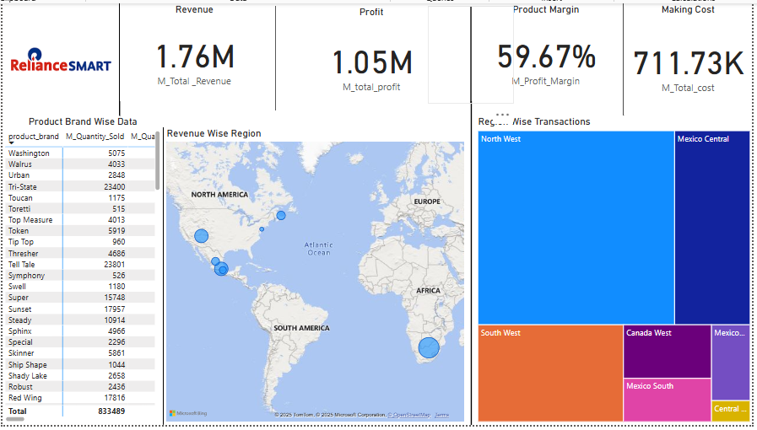

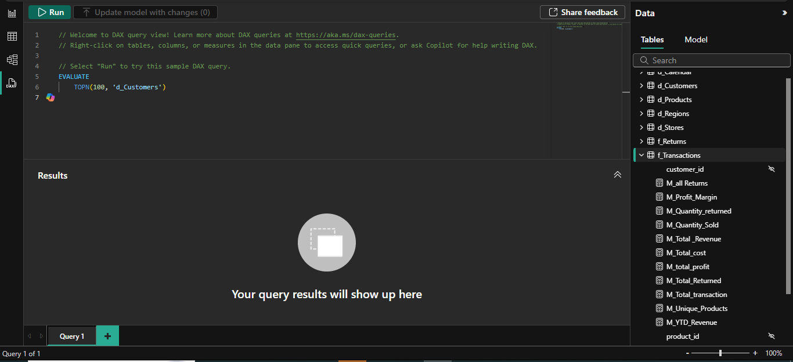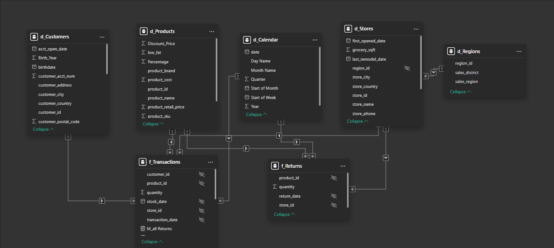

# CONCLUSION

The Power BI dashboard developed for Reliance SMART provides a powerful and interactive platform for analyzing sales data across various product brands and global regions. By integrating key business metrics such as revenue, profit, making cost, and profit margin, the dashboard offers valuable insights that support data-driven decision-making. The use of visual tools like maps, treemaps, and KPI cards enables users to quickly identify trends, assess regional performance, and evaluate product-level profitability.

This project not only enhances visibility into business operations but also demonstrates the effectiveness of using business intelligence tools like Power BI for transforming raw data into meaningful insights. Going forward, this dashboard can be expanded with more granular data, predictive analytics, and real-time updates to further enhance its utility for business strategy and planning.